10.1 Library/WHFreeman/Rogawski_Calculus_Early_Transcendentals_Second_Edition/13_Calculus_of_Vector-Valued_Functions/13.1_Vector-Valued_Functions/13.1.28.pg (adapt to a by hand explaination)
10.1 Library/maCalcDB/setParametric1Curves/ur_pa_1_6.pg (horiz or vert tangents, will need to trim problem)
10.2 Library/WHFreeman/Rogawski_Calculus_Early_Transcendentals_Second_Edition/13_Calculus_of_Vector-Valued_Functions/13.3_Arc_Length_and_Speed/13.3.14.pg (adapt for by hand ?)
10.2 Library/WHFreeman/Rogawski_Calculus_Early_Transcendentals_Second_Edition/13_Calculus_of_Vector-Valued_Functions/13.3_Arc_Length_and_Speed/13.3.29.pg (adapt for by hand)

9.3:
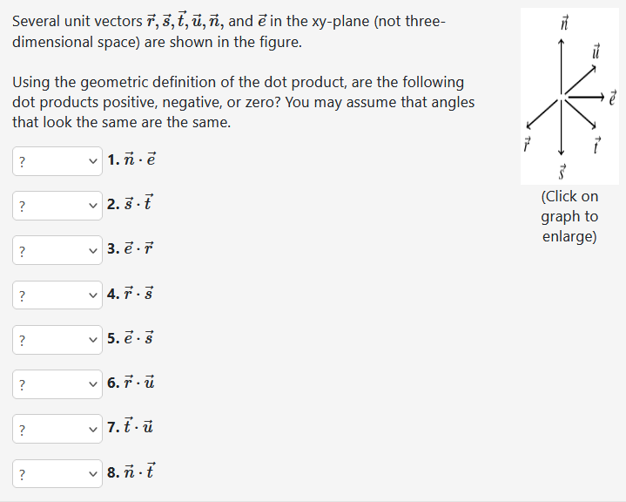
Flux integrals
Compute the flux of 1,2,3 through a plane, a cylinder, a cylinder with top and bottom, and a sphere. Use your work here to answer: If S is a closed surface (explain what this is), what do you think the flux of F through S will be?
Line int param
<!--TODO: Exercise on converting between notations. Ask them what changes in this formula if the vector field changes, etc.-->

